This summer, the Duval County Public Schools Nutrition Department has been hard at work, continuing to feed our students and gearing up for the upcoming school year. Some highlights from June and July include:

Summer Meals
This summer, our team continues to serve meals across the district under the USDA Summer Food Service Program. Our extended meal program offers free nutritionally balanced breakfasts and lunches for children ages 5-18 throughout the community.

In the News
Our team visited The Morning Show at News4Jax to share some kid-approved smart snacking recipes to help kids power through their busy summer schedules and beat the summer heat. From peach salsa and energy bites to watermelon and feta salad, these tasty recipes are as refreshing as they are delicious! Watch the full segment on News4Jax.

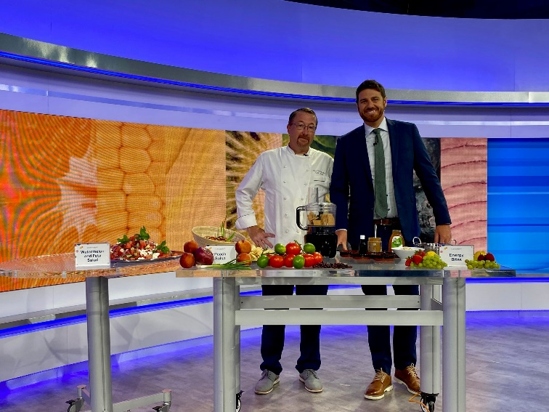
Elementary Signage Refresh
Our team has been installing some fun new pop-art-inspired posters in elementary school serving lines to help liven up the space and welcome the students back with a fresh new look.

Back-to-School Training
To prepare for the coming school year, our team has been gathering for kitchen training to ensure we are ready to reopen better than ever.

Community Engagement
This summer, we’ve been out in the community partnering with local groups to give back to the students of Duval County, including events like:
- Miracle on Ashley Street – event feeding the homeless
- Title 1 Conference – providing information about our free school meal program to attendees
- Cornbread Reading Presentation – providing refreshments for a DCPS teacher/local author’s book reading
- JaxHelps Celebrity Basketball Game with I’m a Star Foundation – sponsoring and participating in the event that raises funds for local homeless students
- Kicks for Kids – shoe drive for local students

